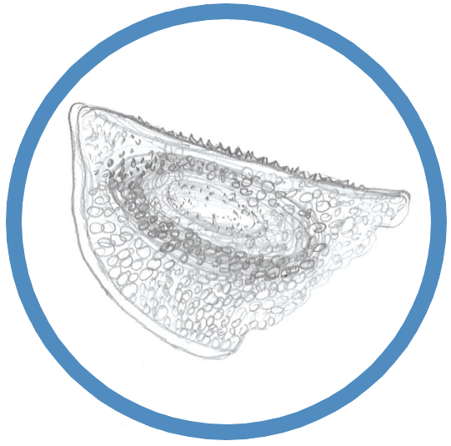
XVII Subfossil Cladocera Workshop
High Tatra Mountains, Slovakia, October 5–7, 2023

First circular

Dear colleagues of the Cladocera and paleolimnology communities,

It is our great pleasure to announce the XVII Subfossil Cladocera Workshop, which will be held
in the High Tatra Mountains in Slovakia (in the Tatra National Park) on October 5–7, 2023.

These workshops focused on subfossil remains of Cladocera in lake sediments – as an important type of proxies in paleolimnology – have emerged from scientific activities of Finnish and Polish colleagues and a close cooperation between them. Atte Korhola organized the first workshop
in Helsinki in 1999 and for a long time, these meetings have been initiated by Kaarina Sarmaja-Korjonen (University of Helsinki) and Krystyna Szeroczyńska, nowadays Edyta Zawisza (Institute
of Geology, Polish Academy of Sciences). Their original, and still very important, purpose was learning to identify Cladocera remains and sharing the knowledge between starting and experienced colleagues. Currently, there are always oral and poster presentations, a microscopic (determination) session, and an excursion. The topics have broadened, but the character of the workshops remains informal and friendly.

Venue
Recreational facility / conference centre “CROCUS”, Kežmarské Žľaby – a settlement near the mountain resort Tatranská Lomnica, in the foothills of the High Tatras in the elevation of 900 m.

The costs: accommodation + full board – EUR 55 per person and night (half board – EUR 48).
Accommodation in CROCUS as well as meals are available also prior/after the workshop.

Workshop structure
Day 0 (Wednesday, October 4) – arrivals, registration, informal dinner-together
Day 1 (Thursday, October 5) – last arrivals and registration, oral and poster sessions, dinner
Day 2 (Friday, October 6) – excursion, social dinner at CROCUS
Day 3 (Saturday, October 7) – microscopic session until midday, lunch, departures

Topic range
Subfossil Cladocera – qualitative and quantitative paleo-reconstructions
Cladocera taxonomy and ecology
Methodology – current trends and best practices
Overviews:
1. Subfossil Cladocera remains in paleolimnology – from the beginnings to current challenges
2. Limnological and paleolimnological studies in the area of the Tatra Mountains (Slovakia, Poland)
3. History of SF Cladocera workshops

Excursion
Hiking to the Cottage at Zelené pleso (the Green Lake, 1,550 m a. s. l.) and back (different options and levels of difficulty), or a trip to the resort Tatranská Lomnica and to the Skalnaté pleso Lake (1,750 m a. s. l.) by cable car.
Travel information
The gate to the Tatras is the town of Poprad, lying south-east of the Tatra mountain range. The town is situated on the west-east European route E50 and the main west-east railway line
in Slovakia. Therefore, there is a good access also from the international airports in Bratislava or Košice (Slovakia), Vienna (Austria), Kraków (Poland), or Prague (Czech Republic). Wizz Air operates direct flights from London to the airport Poprad – Tatry.

All resorts and settlements in the area of the High Tatra Mountains are connected with Poprad by a narrow gauge railway and buses. Kežmarské Žľaby (49.1953314N, 20.2992272E) is situated at
a driving distance of 4 hours from Bratislava (ca. 350 km), about 4.5 hours from Budapest (ca. 270 km), about 2.5 hours from Krakow (ca. 140 km), and 30 minutes from Poprad (ca. 20 km).

Registration date
We would be very grateful if you let us know as soon as possible about your PRELIMINARY interest to participate in the workshop, and send the Registration form to Zuzana until July 25. We do not plan to prepare any Abstract book, just a program with lecture/poster titles.

Please forward this information to anyone who might be interested to join us…
Students and young researchers will be very welcome.

Looking forward to meet you in the Slovak Tatras,

Peter Bitušík, Laci Hamerlík, Zuzana Hořická – the organizing team

Prof. Peter BITUŠÍK, Assoc. prof. Ladislav HAMERLÍK, Department of Biology and Ecology,
Faculty of Natural Sciences, Matej Bel University in Banska Bystrica, Slovakia

Dr. Zuzana HOŘICKÁ, T. G. Masaryk Water Research Institute, Prague, and Institute
of Hydrobiology, Academy of Sciences of the Czech Republic – contact person: zuzana.horicka@vuv.cz, +420 606 625 486

Links
https://mapy.cz/turisticka?vlastni-body&ut=CROCUS%2C%20Ke%C5%BEmarsk%C3%A9%20%C5%BD%C4%BEaby&ut=Tatransk%C3%A1%20Lomnica&ut=Skalnat%C3%A9%20pleso%20Lake%20(cable%20car%20station)&ut=Cottage%20at%20Zelen%C3%A9%20pleso%20Lake&ut=Poprad%20train%20%2B%20bus%20station&ut=Poprad%20-%20Tatry%20international%20airport&uc=9umWIxTtbj3Q1xTkFx9ucKimcFe0qxTxmG9ulkWxTET-9u3rwjbE&ud=49%C2%B011%2743.870%22N%2C%2020%C2%B017%2758.465%22E&ud=49%C2%B010%270.861%22N%2C%2020%C2%B017%275.473%22E&ud=49%C2%B011%2715.498%22N%2C%2020%C2%B013%2756.989%22E&ud=49%C2%B012%2735.230%22N%2C%2020%C2%B013%2717.688%22E&ud=49%C2%B03%2737.643%22N%2C%2020%C2%B017%2744.329%22E&ud=Ve%C4%BEk%C3%A1&x=20.2471097&y=49.1450490&z=12

https://chataprizelenomplese.sk/en/

