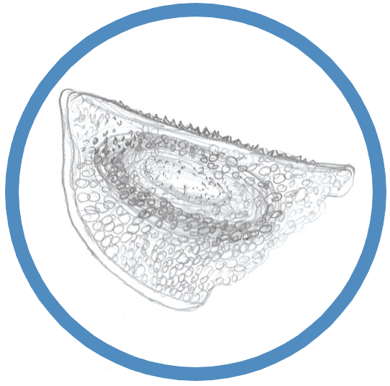
XVII Subfossil Cladocera Workshop
High Tatra Mountains, Slovakia, October 5–7, 2023

Registration form

Please complete this form and send it by e-mail before July 25, 2023 to Zuzana HOŘICKÁ, zuzana.horicka@vuv.cz. A confirmation of your registration will follow by e-mail.

Participant

Name(s) |  |  |  | Title(s)
Surname
Institution
Address
Country
Telephone
E-mail
Gender | Male |  | Female

Accommodation

CROCUS (EUR 55 accommodation + full board / day.person)*
number of nights, dates:
arrival/departure dates:
other accommodation on your own
*mostly twin-bedded rooms

Meals

dinner on October 4 |  | YES |  | NO
full board on October 5-6 |  | YES |  | NO
breakfast on October 7 |  | YES
lunch on October 7 |  | YES
vegetarian |  | YES |  | NO
vegan |  | YES |  | NO
other requirements:
intolerant/allergic to:

Means of transport

Car |  | YES |  | NO
Plane + train to Poprad |  | YES |  | NO
Plane + bus to Poprad |  | YES |  | NO
Do you want us to ensure you  a bus/train ticket from/to Poprad? |  | YES |  | NO

Excursion

Hiking |  | Bus / cable car trip

Contribution(s)

An oral presentation and a poster or two posters are allowed.

Poster presentation
Oral presentation
No presentation

Presentation title

Author(s)

Presentation title

Author(s)

For further information, please contact Zuzana:
Zuzana HOŘICKÁ, zuzana.horicka@vuv.cz, +420 606 625 486

